Problem Sheet 2b - Probability Mass Distributions

## Question 1

1. There are 30 candy covered chocolates in a bag M&M’s. There is a .1 probability that that the candy is red. If X is the number of red M&M’s in the bag.

i Give the binomial probability mass function for X.

**ANSWER:**

$$\text{Pr}\left(k\right)=\left(\begin{matrix}30 \\ k\end{matrix}\right){\left(0.1\right)}^{k}{\left(0.9\right)}^{30−k}, k=0,1,2,...30,$$

where k is the number of red M & Ms.

ii Find the probability of less than 2 red M&Ms in the bag.

**ANSWER:**

n<-30  
k<-1  
MandM<-0:n # Number of Games  
Pr_Red<-0.1 # Probability of Success  
Pr_Reds<-c(dbinom(0:n,n,Pr_Red)) # Binomial Probability   
Q1ii<-c(dbinom(0:k,n,Pr_Red))  
E_X<- n*Pr_Red # Expected Value  
Var_X<-10*Pr_Red*(1-Pr_Red) # Variance

$$\text{Pr}\left(0\right)=\left(\begin{matrix}30 \\ 0\end{matrix}\right){\left(0.1\right)}^{0}{\left(0.9\right)}^{30−0}=0.0423912$$

$$\text{Pr}\left(1\right)=\left(\begin{matrix}30 \\ 1\end{matrix}\right){\left(0.1\right)}^{1}{\left(0.9\right)}^{30−1}=0.1413039$$

$$Pr\left(<2\right)=Pr\left(0\right)+Pr\left(1\right)=0.0423912+0.1413039=0.183695,$$

As it is a Binomial Distribution we can state that the expected number of Red is

$$E\left[k\right]=30×0.1=3,$$

the variance of the distribution is

$$Var\left[k\right]=30×0.1×\left(1−0.1\right)=0.9.$$

The plot below shows the Binomial Distribution M & Ms:

df <- data.frame(MandM,Pr_Reds)  
## Plot  
binomial.p_dist<-ggplot(df, aes(x=MandM,y=Pr_Reds)) + geom_col(width = 0.1)+  
 xlab("Number of Red M and Ms out of 30")+  
 ylab("Pr of Red")+ggtitle("Binomial Distribution")+  
 scale_x_continuous(breaks=0:n)+   
 geom_vline(xintercept = E_X, color = "Red", size=1)+  
 geom_text(aes(x=E_X, label="E[k]", y=max(Pr_Reds)),vjust=2,   
 colour="red", text=element_text(size=18))  
  
 binomial.p_dist

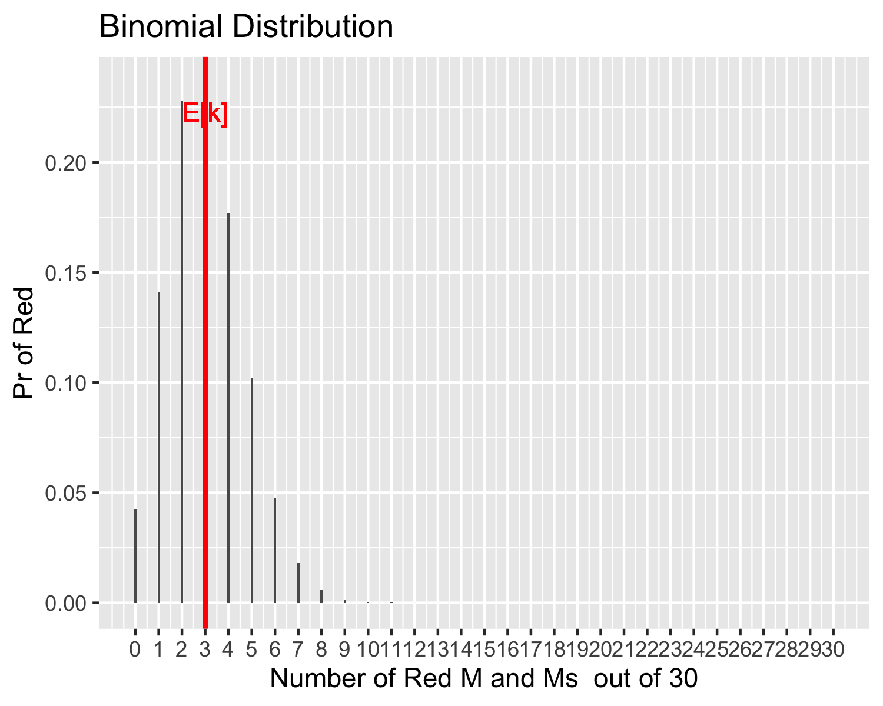

ggsave("Q1.png",dpi=300, width = 4, height = 2)

## Question 2

1. A baby wakes on average 0.25 times every hour.

i If X is the number of times a baby wakes in an hour, give the poisson probability mass function for X. **ANSWER:**

The distribution is described by the average, $λ=0.25$,

$$\text{Pr}\left(k\right)=\frac{{0.25}^{k}e^{−0.25}}{k!}, k=0,1,2,...$$

where $k$ is the number of times the baby wakes every hour.

The expected value of the Poisson Distribution is

$$E\left[k\right]=0.25,$$

with the variance

$$Var\left[k\right]=0.25.$$

The plot below shows the Poisson Distribution for $λ=0.25$ average number of times a baby wakes in an hour:

Wake<-0:20 # Number of Games  
Baby_wakes<-0.25 # Lambda  
Pr_wakes<-c(dpois(Wake,Baby_wakes)) # Poisson Probabilities  
E_X<-Baby_wakes # Expected Outcome  
  
df <- data.frame(Wake,Pr_wakes)  
  
## Plot  
Poisson.p_dist<-ggplot(df, aes(x=Wake,y=Pr_wakes)) +   
 geom_col(width = 0.1)+xlab("Number of Times a Baby wakes in an hour")+  
 ylab("Pr of baby Wakes")+ggtitle("Poisson Distribution")+   
 geom_vline(xintercept = E_X, color = "blue", size=1)+  
 geom_text(aes(x=E_X, label="E[k]", y=max(Pr_wakes)),vjust=2,  
 colour="blue",text=element_text(size=18))  
  
Poisson.p_dist

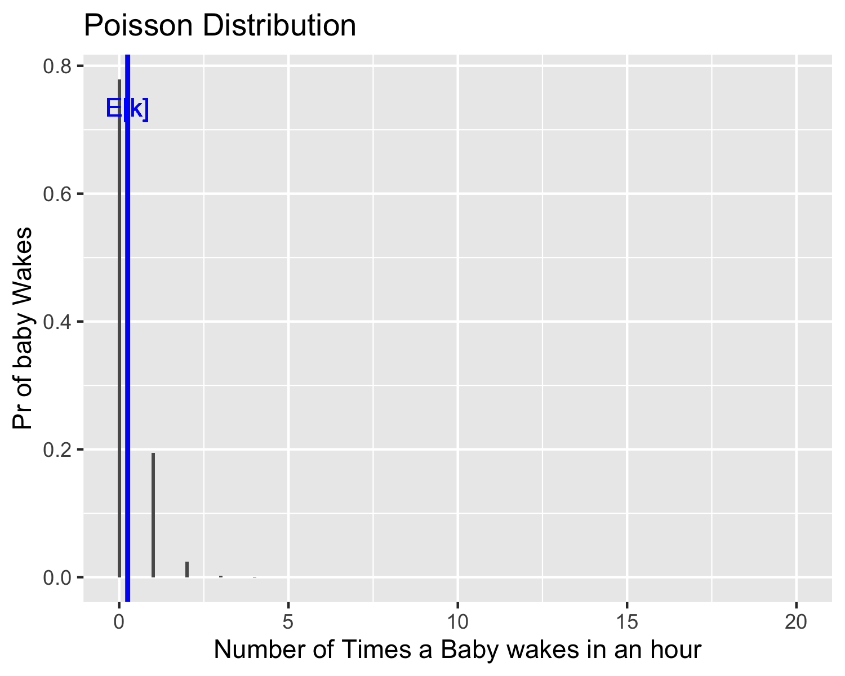

ggsave("Q2i.png",dpi=300, width = 4, height = 2)

ii If X is the number of times a baby wakes in eight hour, give the poisson probability mass function for X.

**ANSWER:**

The distribution is described by the average, $λ=0.25×8=2$,

$$\text{Pr}\left(k\right)=\frac{2^{k}e^{−2}}{k!}, k=0,1,2,...$$

where $k$ is the number of times the baby wakes every 8 hours.

The expected value of the Poisson Distribution is

$$E\left[k\right]=2,$$

with the variance

$$Var\left[k\right]=2.$$

The plot below shows the Poisson Distribution for $λ=2$ average number of times a baby wakes in eight hours:

Baby_wakes<-0.25*8 # Lambda  
Pr_wakes<-c(dpois(Wake,Baby_wakes)) # Poisson Probabilities  
E_X<-Baby_wakes # Expected Outcome  
  
df <- data.frame(Wake,Pr_wakes)  
  
## Plot  
Poisson.p_dist<-ggplot(df, aes(x=Wake,y=Pr_wakes)) +   
 geom_col(width = 0.1)+xlab("Number of Times a Baby wakes in an hour")+  
 ylab("Pr of baby Wakes")+ggtitle("Poisson Distribution")+   
 geom_vline(xintercept = E_X, color = "blue", size=1)+  
 geom_text(aes(x=E_X, label="E[k]", y=max(Pr_wakes)),vjust=2,  
 colour="blue",text=element_text(size=18))  
  
Poisson.p_dist

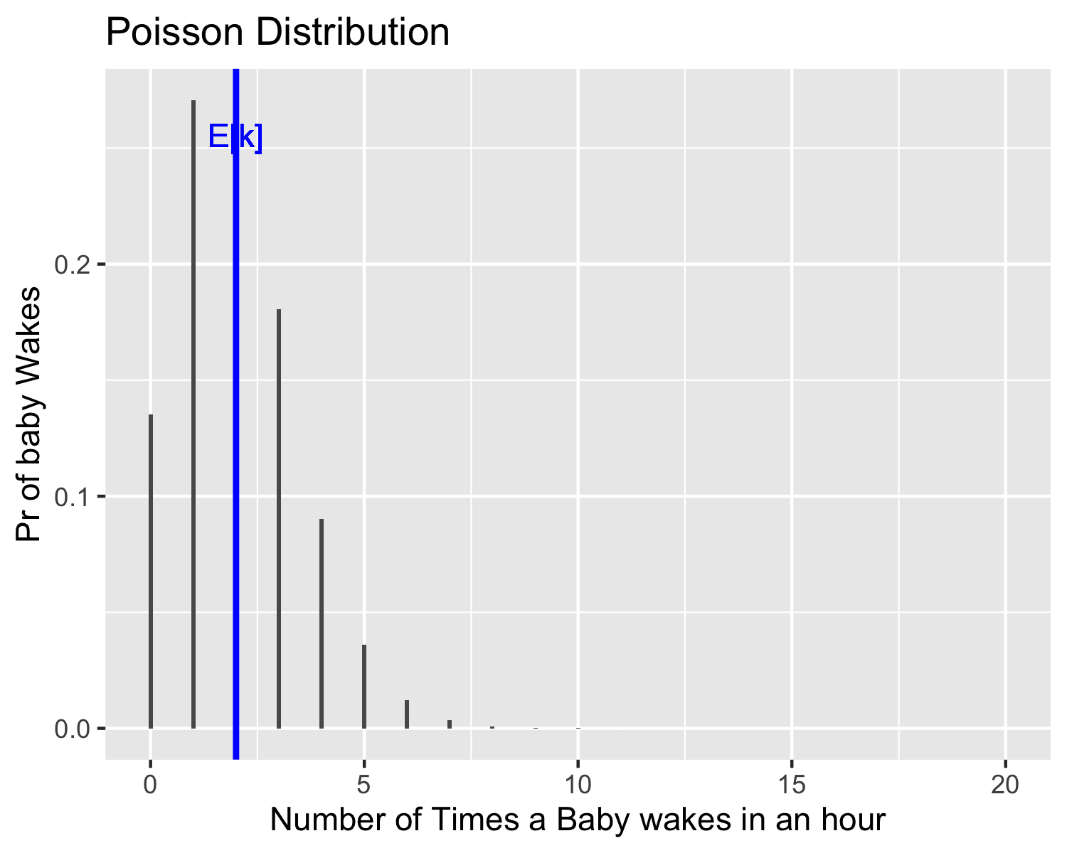

ggsave("Q2i.png",dpi=300, width = 4, height = 2)

iii What is the probability that the baby does not wake during the 8 hours.

**ANSWER:**

Baby_wakes<-0.25*8 # Lambda  
Pr_wakes_zero<-dpois(0,Baby_wakes)

$$\text{Pr}\left(0\right)=\frac{{0.25}^{0}e^{−0.25}}{0!}=0.1353353.$$

 #

## Question 3

1. Give the features of a

i Geometric Experiment.

**ANSWER:**

• Bernoulli Trial • Goes until you “win” • E[X]=1/p, VAR[X]=q/p^2

ii Binomial Experiment.

**ANSWER:**

• Bernoulli Trial • Play a specific number of times • E[x]=np, VAR[X]=npq

iii Poisson Experiment.

**ANSWER:**

• Well known mean • Number of “wins” • E[X]=lambda, VAR[X]=lambda

## Question 4

1. Every day a production line makes 100 computers of which 10% are defective. If X is the number of defective computers in a day.
2. Give the binomial probability mass function for X.

**ANSWER:**

$$\text{Pr}\left(k\right)=\left(\begin{matrix}100 \\ k\end{matrix}\right){\left(0.1\right)}^{k}{\left(0.9\right)}^{30−k}, k=0,1,2,...100,$$

where k is the number of defective computers.

1. Find the probability that there is more than 2 computers defective in a day.

**ANSWER:**

n<-100  
k<-2  
Computers<-0:n # Number of Games  
Pr_Def<-0.1 # Probability of Success  
Pr_Defs<-c(dbinom(0:n,n,Pr_Def)) # Binomial Probability   
Q4ii<-c(dbinom(0:k,n,Pr_Def))  
E_X<- n*Pr_Def # Expected Value  
Var_X<-10*Pr_Def*(1-Pr_Def) # Variance

$$\text{Pr}\left(0\right)=\left(\begin{matrix}100 \\ 0\end{matrix}\right){\left(0.1\right)}^{0}{\left(0.9\right)}^{100−0}=2.6561399×{10}^{−5},$$

$$\text{Pr}\left(1\right)=\left(\begin{matrix}100 \\ 1\end{matrix}\right){\left(0.1\right)}^{1}{\left(0.9\right)}^{100−1}=2.9512665×{10}^{−4},$$

$$Pr\left(2\right)=\left(\begin{matrix}100 \\ 2\end{matrix}\right){\left(0.1\right)}^{2}{\left(0.9\right)}^{100−2}=0.0016232.$$

$$Pr\left(>2\right)=1−Pr\left(≤2\right)=1−\left(Pr\left(0\right)+Pr\left(1\right)+Pr\left(2\right)\right)=1−2.6561399×{10}^{−5}+2.9512665×{10}^{−4}+0.0016232=0.9980551$$

The plot below shows the Binomial Distribution for defective computers:

df <- data.frame(Computers,Pr_Defs)  
## Plot  
binomial.p_dist<-ggplot(df, aes(x=Computers,y=Pr_Defs)) + geom_col(width = 0.1)+  
 xlab("Number of Defective Computers")+  
 ylab("Pr of Defective")+ggtitle("Binomial Distribution")+  
 geom_vline(xintercept = E_X, color = "Red", size=1)+  
 geom_text(aes(x=E_X, label="E[k]", y=max(Pr_Defs)),vjust=2,   
 colour="red", text=element_text(size=18))  
  
 binomial.p_dist

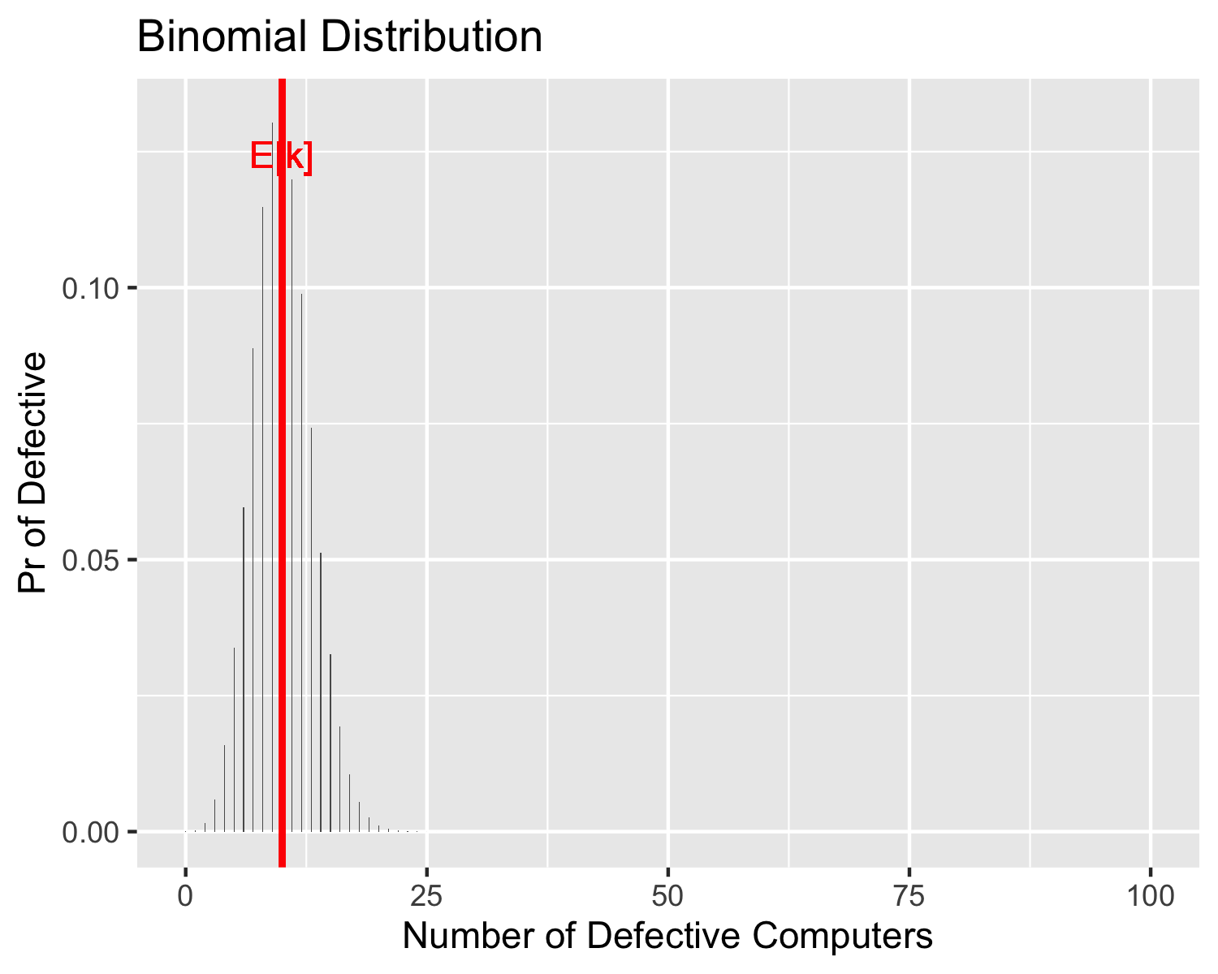

ggsave("Q4.png",dpi=300, width = 4, height = 2)

## Question 5

1. A phone center receives 15 calls every 30 minutes.
2. If X is the number of phone calls in 30 minutes, give the Poisson probability mass function for X.

**ANSWER:**

The distribution is described by the average, $λ=15$,

$$\text{Pr}\left(k\right)=\frac{{15}^{k}e^{−15}}{k!}, k=0,1,2,...$$

where $k$ is the number of phone calls per half hour.

The expected value of the Poisson Distribution is

$$E\left[k\right]=15,$$

with the variance

$$Var\left[k\right]=15.$$

The plot below shows the Poisson Distribution for $λ=15$ average number of calls per half-hour:

Calls<-0:50 # Number of Games  
No_of_Calls<-15 # Lambda  
Pr_Calls<-c(dpois(Calls,No_of_Calls)) # Poisson Probabilities  
E_X<-No_of_Calls # Expected Outcome  
  
df <- data.frame(Calls,Pr_Calls)  
  
## Plot  
Poisson.p_dist<-ggplot(df, aes(x=Calls,y=Pr_Calls)) +   
 geom_col(width = 0.1)+xlab("Number of Phone Calls in a half hour")+  
 ylab("Pr of Phone Calls")+ggtitle("Poisson Distribution")+   
 geom_vline(xintercept = E_X, color = "blue", size=1)+  
 geom_text(aes(x=E_X, label="E[k]", y=max(Pr_Calls)),vjust=2,  
 colour="blue",text=element_text(size=18))  
  
Poisson.p_dist

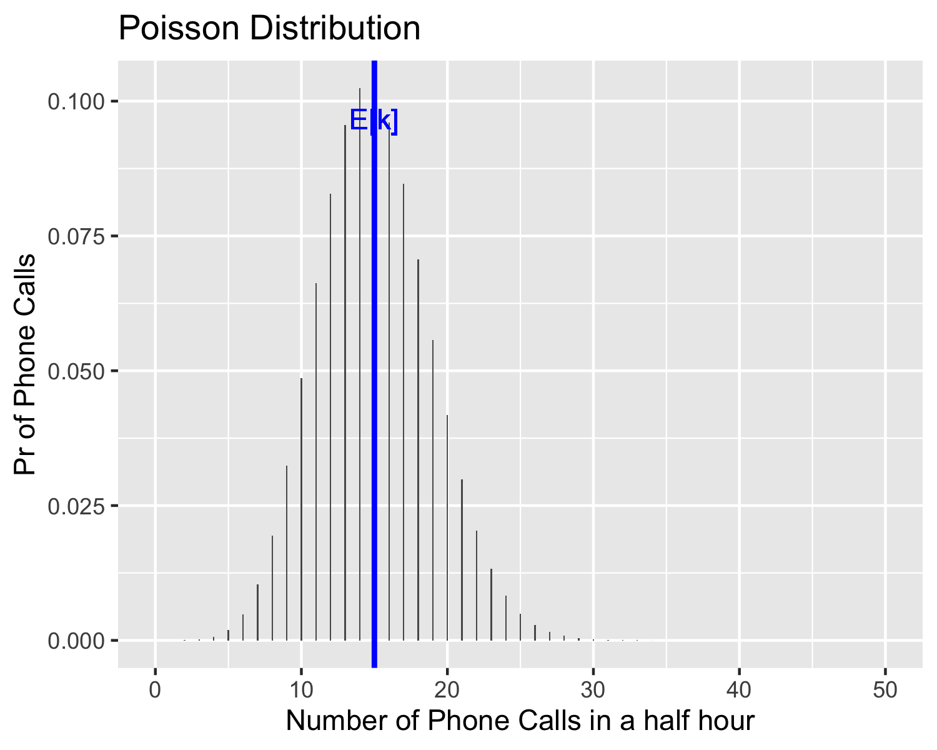

ggsave("Q5i.png",dpi=300, width = 4, height = 2)

1. What is the probability that there will be exactly 10 phone calls in the first 30 minutes and exactly 20 phone calls in the second 30 minutes.

**ANSWER:**

No_of_Calls<-15 # Lambda  
Pr_Calls_10<-dpois(10,No_of_Calls) # 10 Calls Poisson Probability  
Pr_Calls_20<-dpois(20,No_of_Calls) # 20 Calls Poisson Probability  
Pr_Calls_10_then_20 <- Pr_Calls_10*Pr_Calls_20

Probability of 10 calls in the first half-hour:

$$\text{Pr}\left(10\right)=\frac{{15}^{10}e^{−15}}{10!}=0.0486108.$$

Probability of 20 calls in the first half-hour:

$$\text{Pr}\left(20\right)=\frac{{15}^{20}e^{−15}}{20!}=0.0418103.$$

The combination of both:

$$\text{Pr}\left(10\right)×\text{Pr}\left(20\right)=0.0020324.$$